Assignment 4: Text and Sequence Data

BA64061 Advanced Machine Learning Spring 2026
Dr. CJ Wu
Brian Yim
Introduction
The purpose of this assignment was to apply neural network techniques, specifically embedding-based models, to text data and evaluate their performance under different training conditions. This assignment focused on comparing two approaches for representing text data in a sentiment classification task using the IMDB dataset: (1) a learned embedding layer trained from scratch and (2) a pretrained word embedding using GloVe vectors.
A key objective of this experiment was to determine how the amount of training data affects model performance and to identify at what point a learned embedding begins to outperform a pretrained embedding.
Methods
Dataset and Preprocessing
The IMDB dataset was used for binary sentiment classification (positive vs. negative). The following preprocessing steps were applied:
Only the top 10,000 most frequent words were considered.
Each review was truncated or padded to a maximum length of 150 words.
The validation set consisted of 10,000 samples.
The training set size was varied across experiments:
100, 500, 1,000, 2,500, and 5,000 samples.
Models
Two models were constructed and evaluated: 1) Learned Embedding Model and 2) Pretrained Embedding Model.
First, an embedding layer was trained from scratch using only the available training data.
The embedding layer was followed by a flatten layer and dense layers for classification.
This model learns word representations specific to the IMDB sentiment task.
Next, I used Pretrained GloVe (100-dimensional) word embeddings for this model. The embedding layer was initialized with pretrained weights and kept non-trainable. This model leveraged semantic knowledge learned from a large external corpus.
Evaluation
Model performance was evaluated using validation accuracy, and the best validation accuracy across epochs was recorded for each experiment.
Results
With only 100 training samples, the pretrained embedding model outperformed the learned embedding model by a noticeable margin (see Table 1).
Table 1. Initial Comparison (100 Training Samples)
Model | Best Validation Accuracy
Learned Embedding | 0.5009
Pretrained Embedding | 0.5637

On the other hand, Table 2 shows that the pretrained embedding model performs better at smaller training sample sizes, but its improvement is modest as the sample size increases. In contrast, the learned embedding model improves substantially with more data and outperforms the pretrained embedding model once the training sample size reaches 2,500 and above.
Table 2. Performance Across Training Sample Sizes
Training Samples | Learned Embedding | Pretrained Embedding
100 | 0.5083 | 0.5680
500 | 0.5452 | 0.5984
1000 | 0.6164 | 0.6268
2500 | 0.7905 | 0.6520
5000 | 0.8180 | 0.6818

Discussion
The results show a clear pattern in how model performance depends on the amount of training data.
Small Data Scenario
When the number of training samples was very limited (100, 500, and 1,000 samples), the pretrained embedding model consistently outperformed the learned embedding model. This is because pretrained embeddings already contain semantic information learned from a large corpus, allowing the model to generalize better even with minimal training data.
In contrast, the learned embedding model performed poorly at very small sample sizes, with validation accuracy near random guessing (~0.50). This indicates that the model was unable to learn meaningful word representations from such limited data.
Larger Data Scenario
As the2500 training sample size increased, the learned embedding model improved significantly. At 2,500 samples, it surpassed the pretrained embedding model, and at 5,000 samples, it achieved substantially higher accuracy.
This improvement suggests that once sufficient data is available, the learned embedding can capture task-specific patterns more effectively than pretrained embeddings, which remain fixed and may not fully align with the sentiment classification task.
Turning Point
The crossover point appears to occur between 1,000 and 2,500 training samples, where the learned embedding model begins to outperform the pretrained approach (see Figure 1).
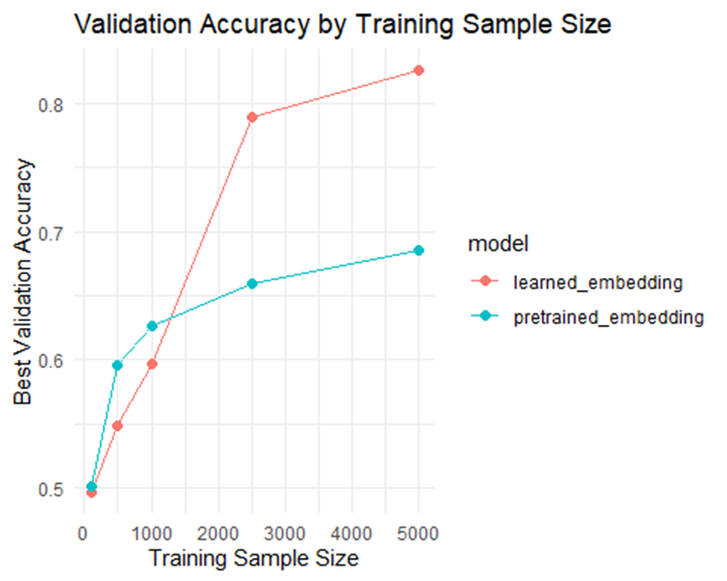
Figure 1. Validation Accuracy by Training Sample Size

Conclusion
This study demonstrates that the effectiveness of embedding methods depends heavily on the amount of available training data. Pretrained embeddings are more effective in low-data scenarios because they provide prior semantic knowledge. Learned embeddings become superior when sufficient training data is available, as they can adapt more specifically to the task.
Overall, the results highlight the importance of selecting modeling approaches based on data availability. When data is scarce, pretrained embeddings are preferable, while learned embeddings are more powerful when larger datasets are available.

